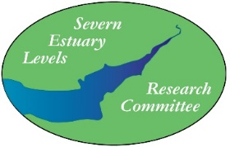

SEVERN ESTUARY LEVELS RESEARCH COMMITTEE

RESEARCH GRANT APPLICATION

Deadline for applications: 1st of October
Please return the completed form to Richard.brunning@swheritage.org.uk

SELRC provides small grants towards research into the archaeology of the Severn Estuary and the surrounding coastal floodplains in Wales and England.

Name of applicant:

Organisation name:

Contact email:

Contact address:

Brief details of research being undertaken (max 500 words)

What will the grant be spent on?

What amount is being applied for (max £650)?

What funding has been obtained from other sources?

If your desired amount cannot be granted, would a smaller amount still be useful? If yes, what would be your minimum amount that would be useful?

What is your publication plan for the work? It is expected that the results of the research would be submitted in some form for publication in Archaeology of the Severn Estuary. This could take the form of anything from a brief interim note to a full final publication.

Referee/Reference
For application verification purposes (if required)
- Name and position:
Contact email:

