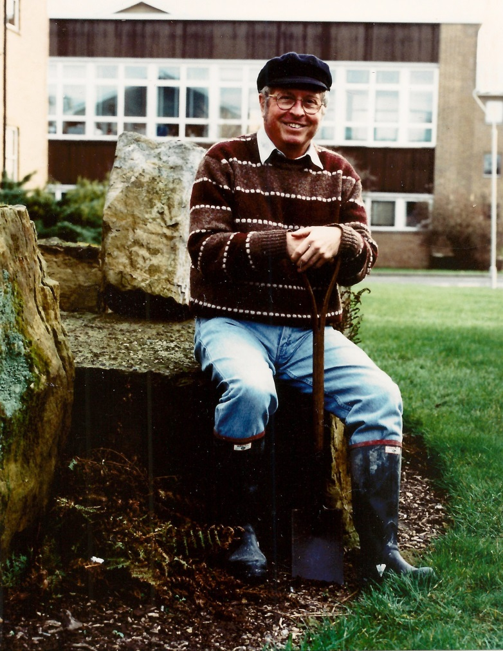
Professor John Allen
Left: in 1997 on the occasion of receiving the Penrose Medal of the Geological Society of America. Right: addressing a Severn Estuary Levels Research Committee field meeting on the seawall at Peterstone in 2007.
Professor John R.L. Allen 25.10.1932-18.10.2020
John Allen applied his outstanding knowledge of sedimentary geology to pioneering research and teaching in the interdisciplinary field of Geoarchaeology. Unusually among generations of geologists fixated by old hard rocks Allen was alive to the significance of Ice Age, Post-glacial and today’s sediments to sciences founded on principles of uniformitarianism (the present is the key to the past).
His early career in Geology included a first class degree and postgraduate research at Sheffield followed by an appointment to a research fellowship at Reading University in 1958 followed by a lectureship in 1961. He remained at Reading teaching and researching for an outstandingly productive 62 year career. He became a Professor of Geology at the young age of 39, then Director of the Postgraduate Research Institute for Sedimentology from 1988. The Institute played an important role in training for the petroleum industry. He was an authority of the Old Red Sandstone and the coastal geomorphology and sediments of Nigeria. Following nominal retirement, he became Emeritus in 2001 and from 1998 made a major contribution to the teaching of MSc Geoarchaeology. Such was the significance and breadth of his research that John was elected a Fellow of the Royal Society in 1979 and a Fellow of the Society of Antiquaries in 1991. He was awarded a number of medals in recognition of his research including the Lyell Medal of the Geological Society of London (1980) and the Penrose Medal of the Geological Society of America (1996). His textbooks include Principles of Physical Sedimentology (1985) and Geology for Archaeologists (2017).
His transition from hard rock geology to the study of more recent Pleistocene and Holocene sediment sequences was characterised by meticulous fieldwork and produced a wealth of papers on the sediment sequence of the Severn Estuary. These have laid the foundations for the study of coastal sediments and their archaeology and history much more widely. In the 1980s he identified a sequence of Severn Estuary wide sedimentary formations, significant both in environmental history and in establishing the date of the many archaeological finds being made by Derek Upton and others. Discovery of ditches demonstrated that parts of the Levels had been drained by the Romans and the history of land claim in the medieval and post medieval period were also investigated (with Michael Fulford). Geochemical studies (with Joy Rae) connected some of the more recent formations with industrial pollution histories. Allen also published on the Pleistocene landforms and beaches of the Severn, and developed techniques for research on human and animal footprint-tracks and prehistoric and historic archaeological sites. His latest work in the Severn Estuary involved particularly detailed investigation of sedimentary sequences, demonstrating the existence of annually laminated sediments and complex mid-Holocene cycles of erosion, sedimentation and palaeochannel formation (with Petra Dark and Simon Haslett). All these studies are relevant to the history of environmental and climatic change and essential to an understanding of the context of the abundant archaeological evidence of all periods which is increasingly identified as these sediments erode. Allen was a much valued source of collaboration and advice on many archaeological projects in the Severn Estuary and beyond. He was Chair of the Severn Estuary Levels Research Committee and (with Alex Brown) edited Archaeology in the Severn Estuary, a publication to which he made many contributions on diverse topics. He also applied his innovative sedimentary and landscape archaeological approach to coastal areas more widely, publishing on Romney Marsh and the North Norfolk Coast where he holidayed with his family for many years and led Reading student field courses for two decades.
As his active fieldwork in the rather difficult intertidal environment of the Severn Estuary decreased in his mid 70s, Allen turned his research attention to terrestrial matters: the building stones of Norfolk, publishing on Carrstone (2004); the building stones and whetstones of Roman Silchester (2013-4); the geological materials used in the kerbstones of Reading and the building materials used by Victorian church builders in Berkshire and north Hampshire (2007, 2008, 2009). In each of these research topics his geological knowledge was applied in ways which illuminated the social, economic and logistical significance of topics not previously considered.
John died after a short illness a week before his 88th birthday. He is survived by his wife Jean, his constant companion and support for many years and their four surviving children Stephen, Jamie, Hugh and Catherine, another son Peter predeceased John.

Martin Bell

